Assignment 6.01: Work, Work, and more Work!

- Kool Aid man breaks down a wall using a force of 1700 N. He pushes the wall a distance of 2 meters. What is the amount of work he does?
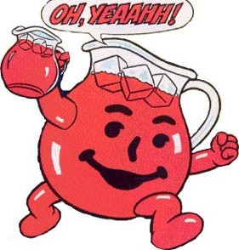

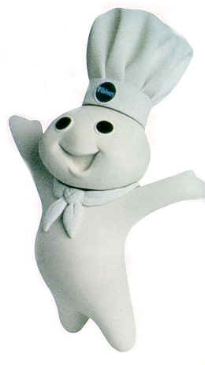
- You see the Pillsbury doughboy and decide to roll him into a cookie. You roll the pin a distance of 0.2 meters, using a force of 6 Newtons. What is the amount of work that you do?

- Luigi uses a hammer to smash one of his enemies. He uses a force of 450 N to push his opponent back a distance of 1.5 meters. If he hits the enemy at a 40 degree angle, what is the amount of work he did?
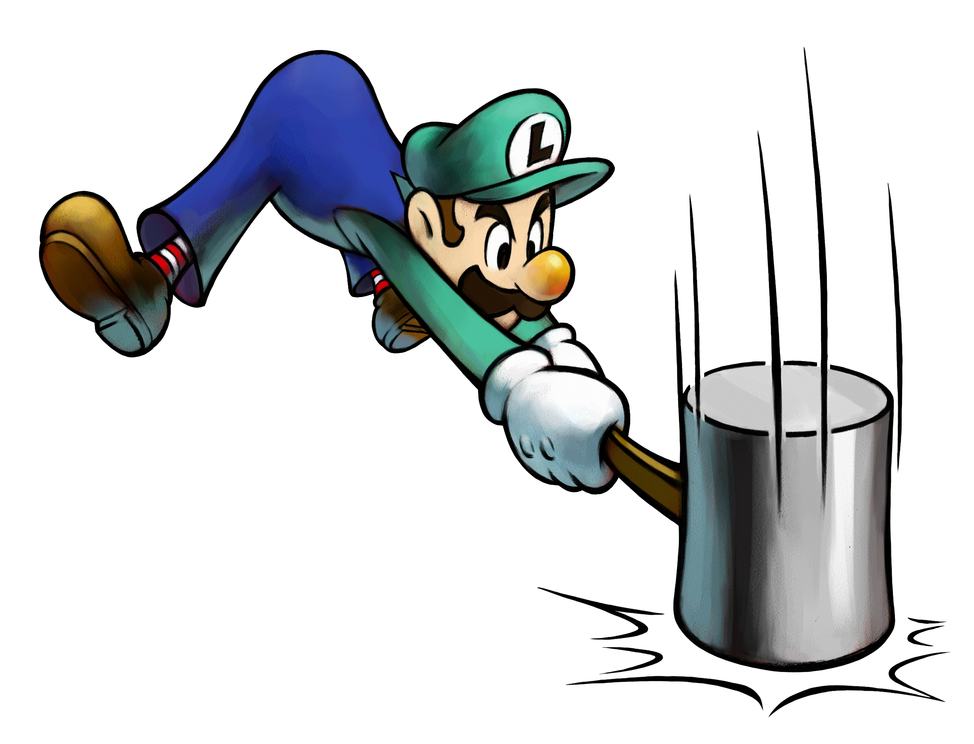

- Riachu blasts his enemy using a charge beam that delivers 70 J of work. His enemy flies backward 2.5 meters at a 25 degree angle. What is the amount of force that his enemy experienced?
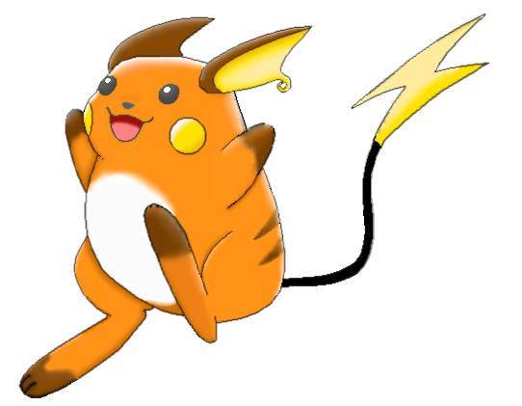

- The fighting Irishman of Notre Dame decides that the Florida Gators have gone too far this time. He delivers an upper-cut packed with 1,300 J of work. If the Florida Gator feels a force of 200 newtons at a 30 degree angle above horizontal, what is the distance the gator will travel?


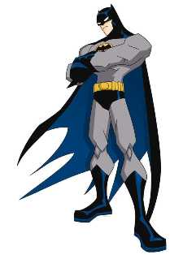
- Batman is 95 kg in mass. How much work does he do when he climbs up the side of a building that is 220 meters tall?

- Megatron is attacking, and Optimus Prime has come to save the day. Optimus Prime sets his blaster on the 15,000 J setting, and blasts megatron in the chest. If megatron was moved a distance of 15 meters, and he feels a force of 3,000 N, what is the angle at which the blast hit him?


- The power rangers are fighting the usual evil creations of the evil overlords bent on world domination. From a flying jump, they blast the monster with a force of 140,000 N, at an angle of 25 degrees. The monster is pushed back 100 meters, along the ground. What is the amount of work that the power rangers do?

